RAMANUJAN COLLEGE

University Of Delhi



Name: - JAGRAV

Course: - B.Sc. (H) Computer Science Roll No.: - 20221465

Practical: Computer network

Q1. To Study basic network command and Network configuration commands.

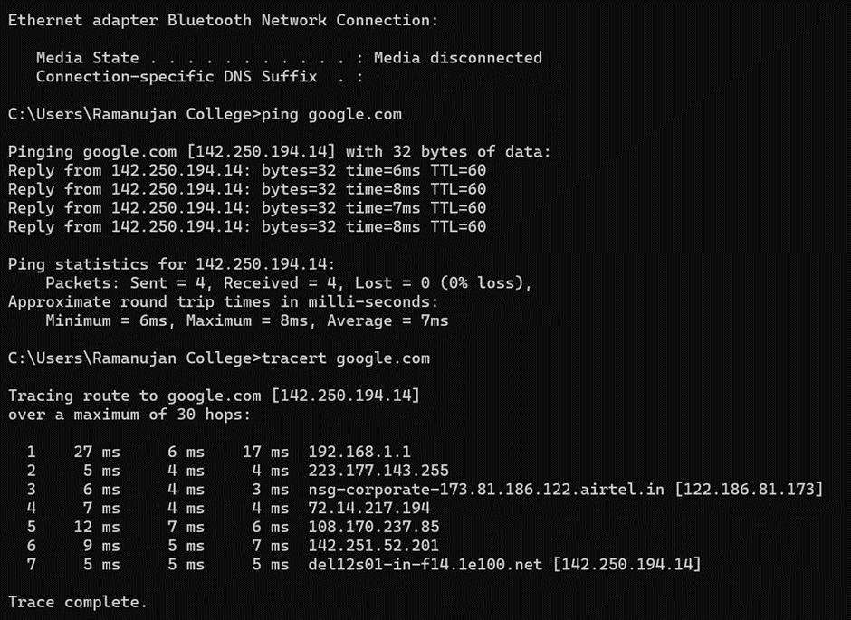



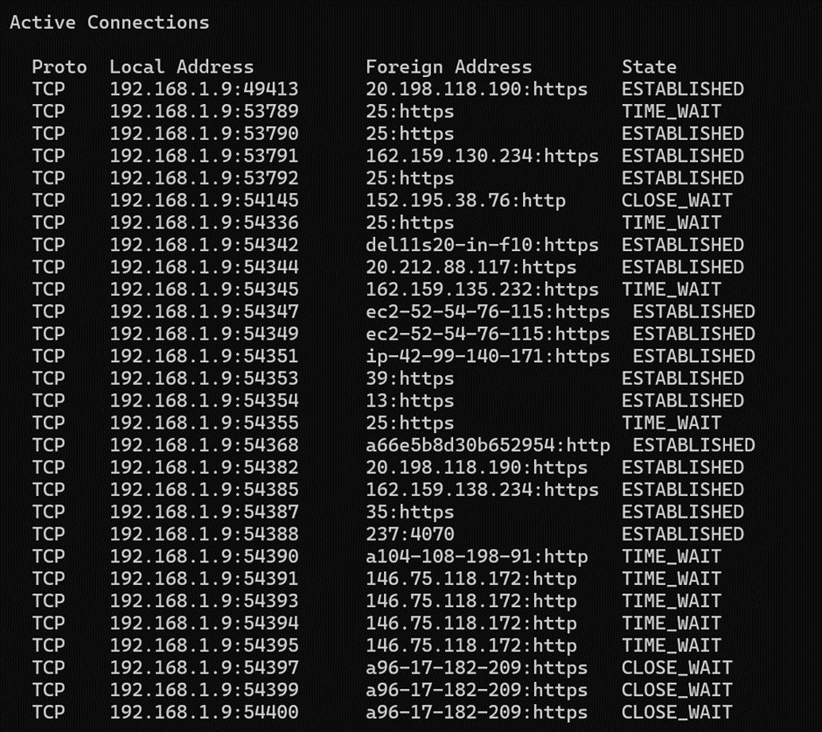

Q2. To study and perform PC to PC communication.

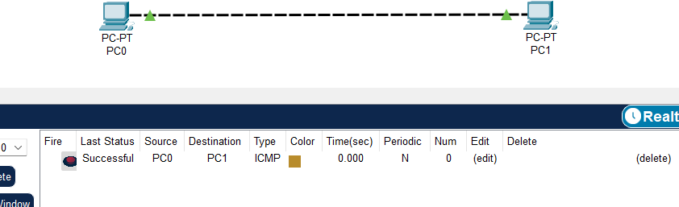

Q3. To create Star topology using Hub and Switch.

1. Using Switch
2. using Hub

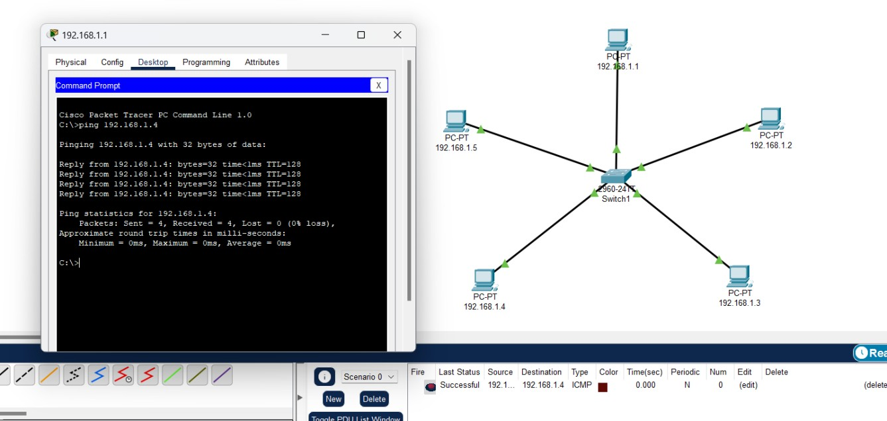

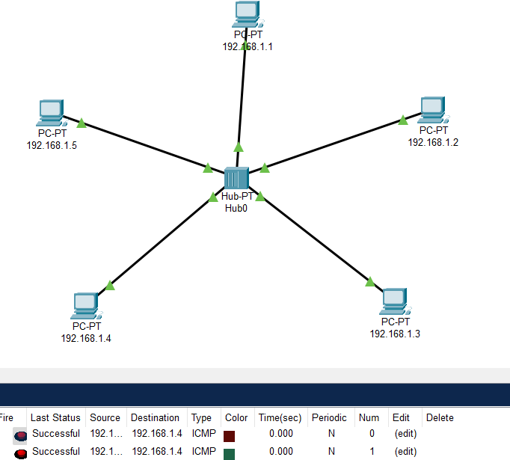

Q4. To create Bus, Ring, Tree, Hybrid, Mash topologies.

1. Bus Topology
2. Tree Topology

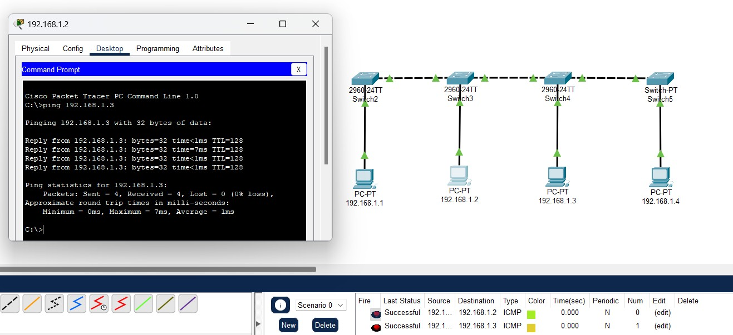

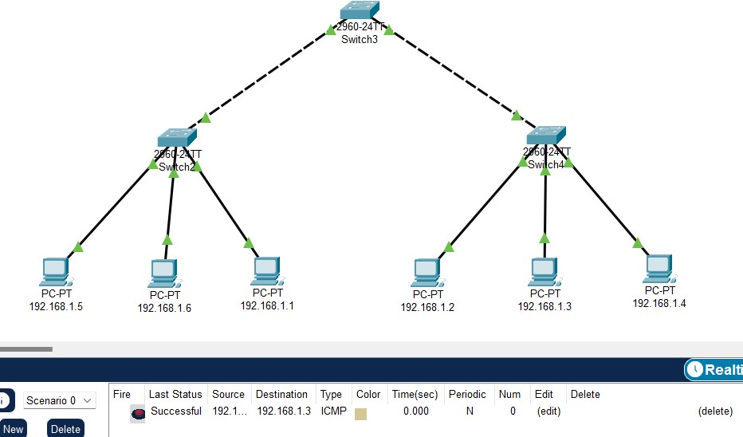

1. 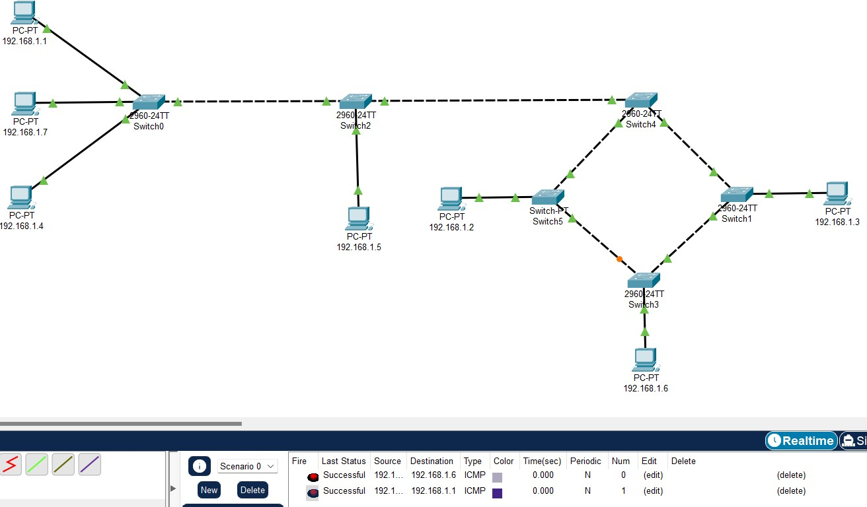Hybrid Topology
2. Mash Topology

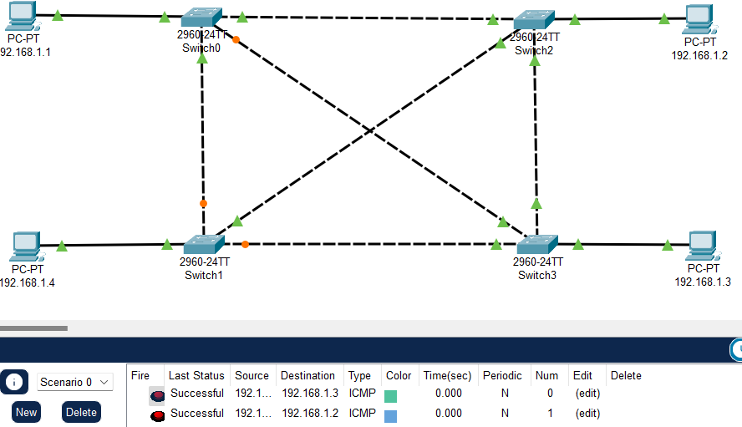

Q5. Perform an initial Switch configuration.

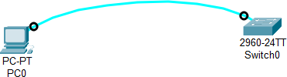

* + Name

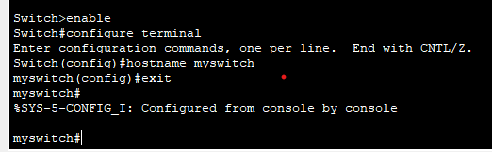

* + password

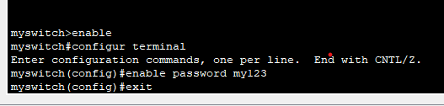

Q6. Perform an initial Router configuration.

* + Host Setting

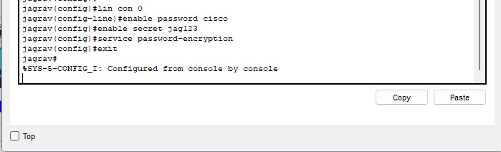

* + Set a message of the day (MOTD) banner for the users.

1. 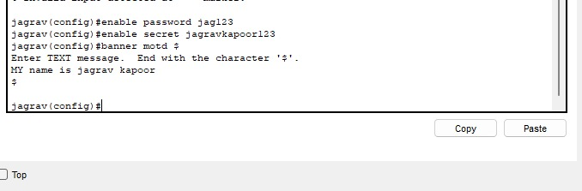
   * To configure the Line Control password
2. 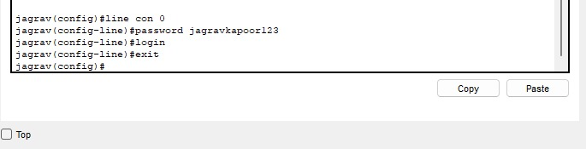
   * Enable secret follow the below commands:
3. 

Q7. To implement Client-server Network.

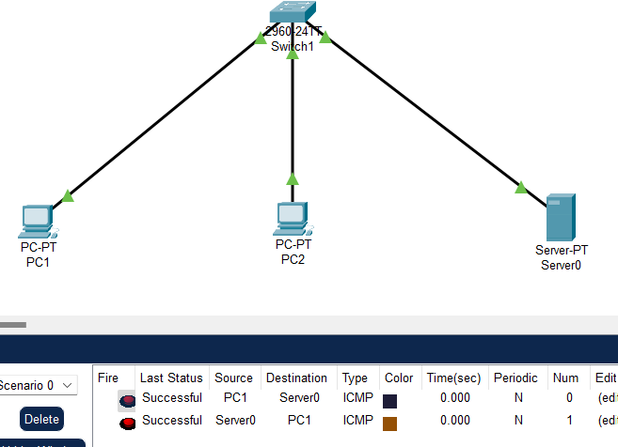

* + Step 1. In any pc go to web server.

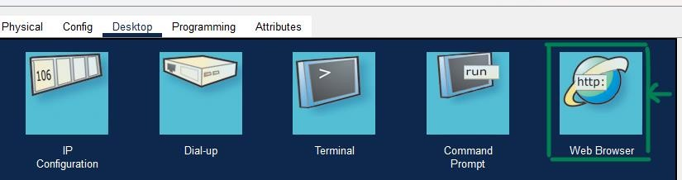-> Step 2. Enter IP address of server connected to your

switch in web server URL. Then press GO.

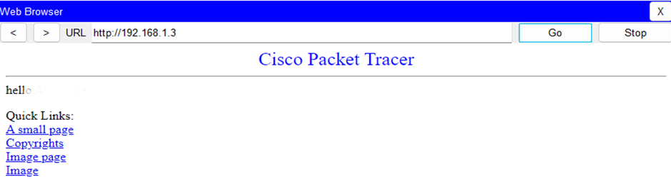

Q8. To implement connection between devices using router.

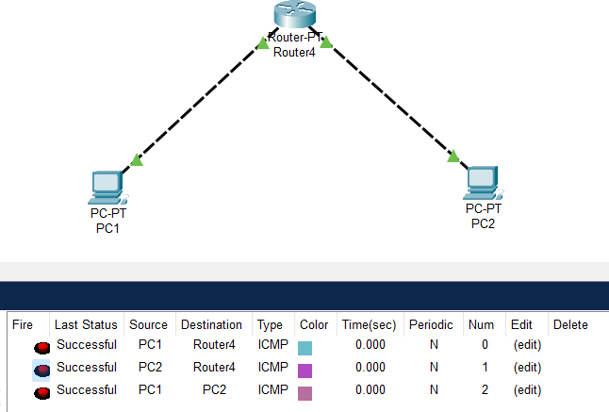

* + Router Config

